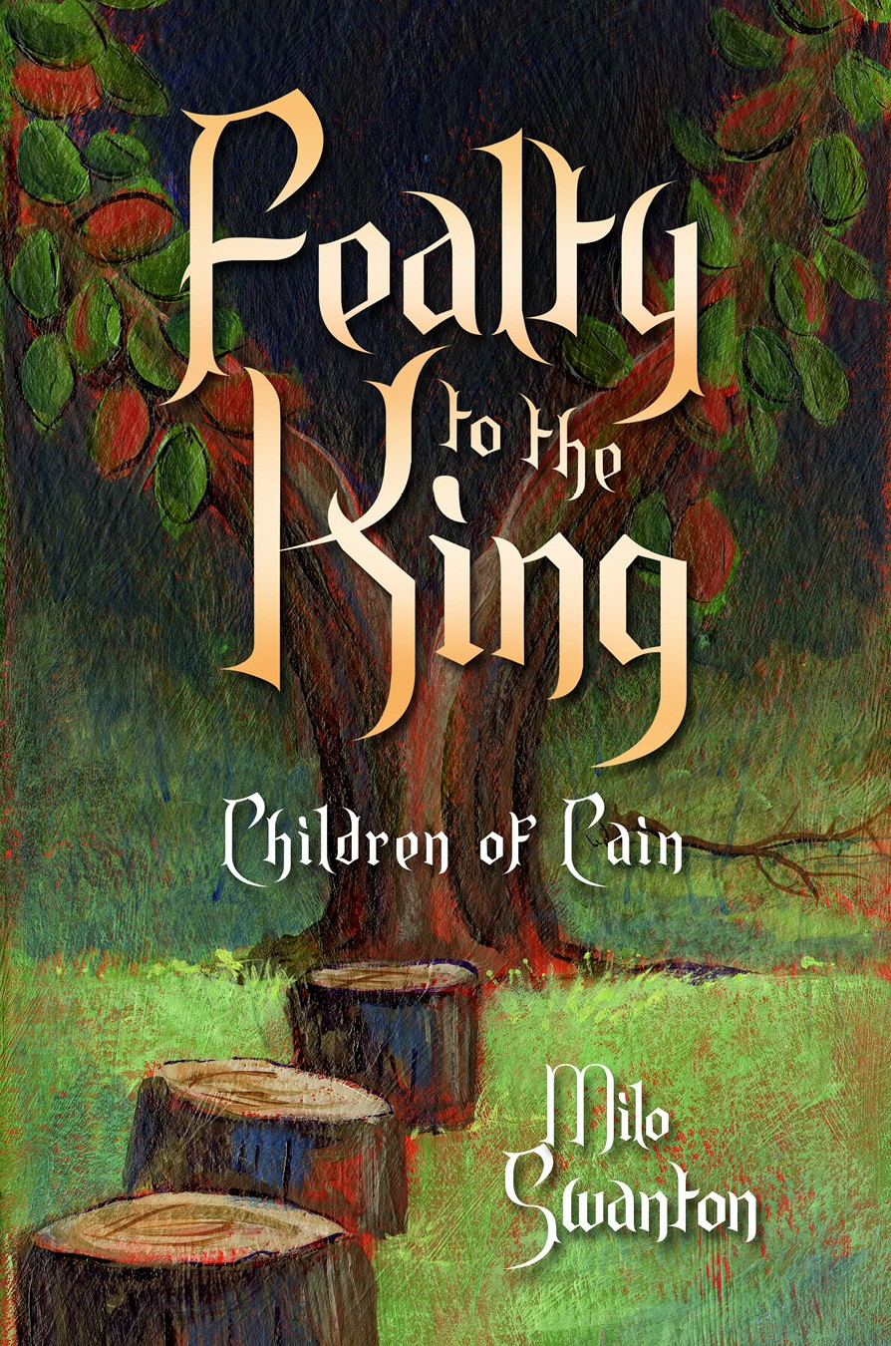
Fealty to the King
Author: Milo Swanton
ISBN: 978-1-940014-27-2 (paperback)
ASIN: B00NG1EAFQ (eBook)
Category: Fiction, High School Age & Up,
Historical Fantasy, Low Fantasy
Book Size: 6x9 (print), 3978 KB (eBook)
Page Count: 456 (print), 415 (eBook)
Price: $15.99 (print), $5.99 (eBook)
Launch Date: September 8, 2014
Publisher: Wise Ink Creative Publishing
Pub. Contact: Amy Quale, amy@wiseinkpub.com
Author Contact: Milo Swanton
10800 Rich Ave. S
Bloomington, MN 55437
email@miloswanton.com | 952-884-8279
Website: www.miloswanton.com
Distributor: Itasca Books Distribution & Fulfillment
5120 Cedar Lake Road
Minneapolis, MN 55416
Dist. Contact: Mark Jung
mjung@stantonpub.com | 1-800-901-3480

Synopsis
As the fourth son of the former clanlord of the Herkt, Brutez wasn’t meant to rule. But finding himself in conflict with the violent current leader over a captured enemy warrior, he challenges the clanlord for leadership and changes his destiny.

Brutez is soon drawn into the wars among the neighboring clans and tribes. He has a vision for a unity they’ve never known, but peace comes at great price. Warfare is dangerous, and politics are even deadlier.

Fealty to the King is About the Rise of a People and a Nation.
Fealty to the King is a sweeping, epic tale of warrior clans and tribes. Of discovery, knowledge, and faith. Of the founding of a nation. Of greatness.

Author Bio
Milo Swanton grew up in Wisconsin and earned a bachelor’s degree in computer science and mathematics. His software engineering career included work on military, medical device, and air traffic control applications. He lives with his wife and mother-in-law in Minnesota.

